Child development within the family and society

Families In Transitions

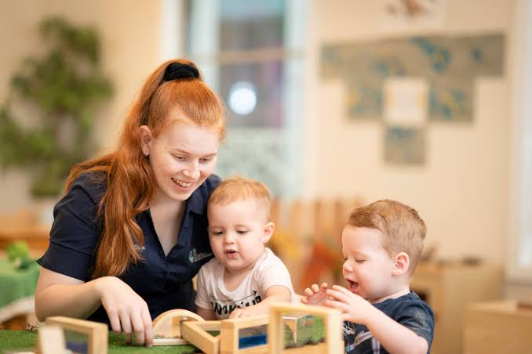

Early Childhood Education in Canada


Early Childhood Education and Care (ECEC) across Canada builds the foundation for lifelong learning through play-based curricula and child-centered exploration. The sector is currently undergoing a massive national transformation via the Canada-Wide Early Learning and Child Care (CWELCC) system to improve affordability, expand licensed spaces, and support registered educators.
Core Pedagogical Approach
- Play-Based Learning: Canadian systems reject early rigid academics in favor of intentional play. Activities like storytelling, tactile exploration, and building blocks are designed to naturally develop literacy, motor skills, and social cooperation.
- Inquiry-Driven Curriculum: Educators co-construct curriculum pathways based on children's natural questions, focusing heavily on creative arts and outdoor environmental engagement.
- Inclusivity & Diversity: Modern programs prioritize child-centered equity, ensuring learning environments accommodate diverse cultural backgrounds and varied learning needs.

Key System Elements
Aspect | Description
System Delivery | Comprises a mix of licensed non-profit centers, home daycares, preschools, and publicly funded school-board Kindergarten programs.
The Workforce | Managed by Early Childhood Educators (ECEs) who possess professional post-secondary credentials, alongside assistants (ECEAs) providing vital operational support.
Protected Titles | To protect public trust, individuals must belong to a regulatory body (like the College of ECEs in Ontario) to legally practice as an ECE.

Ways to involve families in ECA.
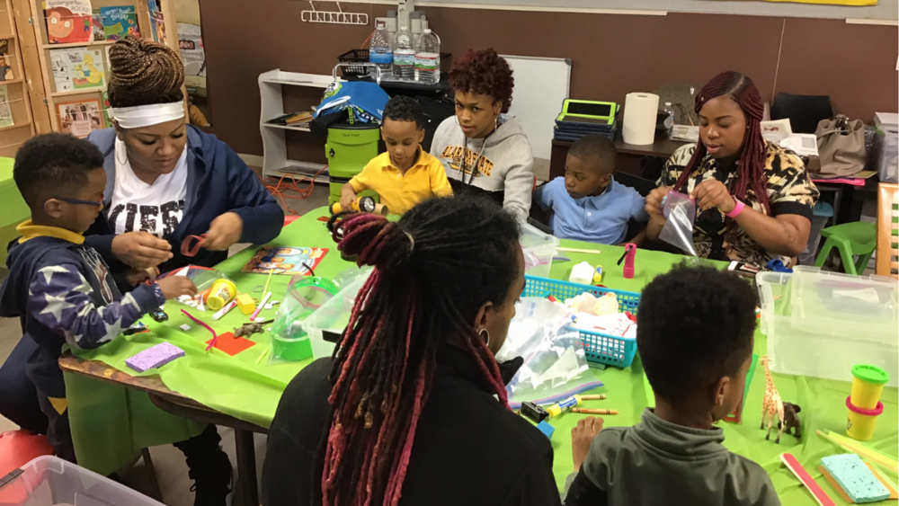

Involving families in Early Childhood Education (ECE) builds a vital bridge between a child’s home and their learning environment. When families and educators collaborate, children experience greater emotional security, better social development, and more consistent learning patterns.
Effective family engagement moves beyond occasional updates—it focuses on building genuine, bidirectional partnerships.

Daily and Digital Communication
- Digital Portfolios: Use dedicated childcare apps to share real-time photos, learning milestones, and daily routines, giving parents an instant window into their child's day.
- Two-Way Communication Logs: Maintain brief, accessible digital or paper journals for infants and toddlers to track sleep, nutrition, and emotional shifts between home and the center.
- Warm Welcomes and Goodbyes: Optimize drop-off and pick-up windows as brief, meaningful touchpoints to exchange positive anecdotes and establish safety.

Classroom and Curriculum Collaboration
- Cultural and Expertise Sharing: Invite family members to share their heritage, traditions, unique talents, or professions through storytelling, music, or cooking activities.
- Lending Libraries: Create take-home backpacks filled with books, sensory materials, or simple games that allow families to extend classroom inquiry-based projects at home.
- Documentation Panels: Display visible, child-led learning stories near classroom entrances, prompting parents to comment or add their own reflections on the project.

Family Events and Leadership
- Flexible Community Gatherings: Host diverse events like weekend family picnics, breakfast gatherings, or evening open houses to accommodate varied working schedules.
- Parent Advisory Committees: Establish a parent board to invite family input on program policies, field trips, special events, and community advocacy.
- Workshops and Resources: Provide casual information sessions on topics families care about, such as positive guidance strategies, speech development, or managing sleep transitions.

The issues facing families in transitions

Family transitions in early childhood education—such as transitioning from home to a childcare center, moving between age groups (infant to toddler), or graduating to kindergarten—can be deeply challenging. While these milestones represent growth, they disrupt established routines and can trigger significant stress for the entire family unit.
Understanding these issues allows educators and families to co-create smoother, more supportive pathways.
Emotional and Psychological Stressors
- Separation Anxiety: Both children and parents frequently experience intense anxiety during drop-offs, driven by a fear of the unknown or guilt over leaving the child.
- Loss of Identity and Connection: Parents often feel a sense of loss as their role as the primary caregiver shifts to include an educator, sometimes worrying about the strength of their bond with the child.
- Emotional Regression: Children under stress may temporarily regress in developmental milestones, showing changes in sleep patterns, increased tantrums, or a resurgence in wetting accidents.

Structural and Logistic Hurdles
- Abrupt Routine Shifts: Moving to a new environment means adapting to unfamiliar schedule structures, such as rigid nap times, altered eating schedules, or different behavioral expectations.
- Information Overload: Families are often inundated with new policies, digital apps, emergency forms, and staff names all at once, leading to cognitive fatigue.
- Financial Strain: Transitions to new care setups or kindergarten can alter a family's subsidy status, fee structures, or transportation costs, adding unexpected financial pressure.
Communication and Relationship Gaps
- Inconsistent Quality Care: Moving from a deeply trusted caregiver to a new, unfamiliar team requires rebuilding relational trust from scratch, which takes significant time.
- Cultural and Language Disconnects: If transition materials or new educators do not reflect or accommodate a family's home language and cultural practices, the family can feel alienated.
- Lack of Continuity: Critical information regarding a child's unique sensory preferences, soothing techniques, or medical history can sometimes be lost during administrative handoffs between classrooms or centers.

Course Title: Early Childhood Assistant
Activity: Families In Transitions
Batch: #7
Submitted By: Manju Vinod Palakkal
Date: September 30, 2026

